**DAILY ONLINE ACTIVITIES SUMMARY**

|  |  |  |  |  |  |  |  |  |
| --- | --- | --- | --- | --- | --- | --- | --- | --- |
| **Date:** | **12/06/2020** | | | | | **Name:** | **RITIKA KULKARNI** | |
| **Sem& Sec** | **4thSEM. & ‘B’ SEC.** | | | | | **USN:** | **4AL19CS403** | |
| **Online Test Summary** | | | | | | | | |
| **Subject** | | **AADALITHA KANNADA** | | | | | | |
| **Max. Marks** | | **25** | | **Score** | | | **19** | |
| **Certification Course Summary** | | | | | | | | |
| **Course** | **Introduction of Information Security** | | | | | | | |
| **Certificate Provider** | | | **Greatlearning**  **Academy** | | **Duration** | | | **5 Hrs.** |
| **Coding Challenges** | | | | | | | | |
| **Problem Statement:**   1. **A prime number is a natural number greater than 1 that has no positive divisors other than 1 and itself. The first few prime numbers are {2, 3, 5, 7, 11, ….}. The idea to solve this problem is to iterate the val from start to end using a for loop and for every number, if it is greater than 1, check if it divides n. If we find any other number which divides, print that value** | | | | | | | | |
| **Status: Executed** | | | | | | | | |
| **Uploaded the report in Github** | | | | | **Yes** | | | |
| **If yes Repository name** | | | | | <https://github.com/ritikakulkarni> | | | |
| **Uploaded the report in slack** | | | | | **Yes** | | | |

**Online Test Summary: AADALITHA KANNADA test was scheduled from 11:00 am to 11:25 am. The portion for the IA was all module there were 25 questions and the time assigned was 25 minutes the questions were mcq type. But there was an issue with the time mentioned, so that we got only 30mins. to finish the test. The time was not sufficient to answer all the questions.**

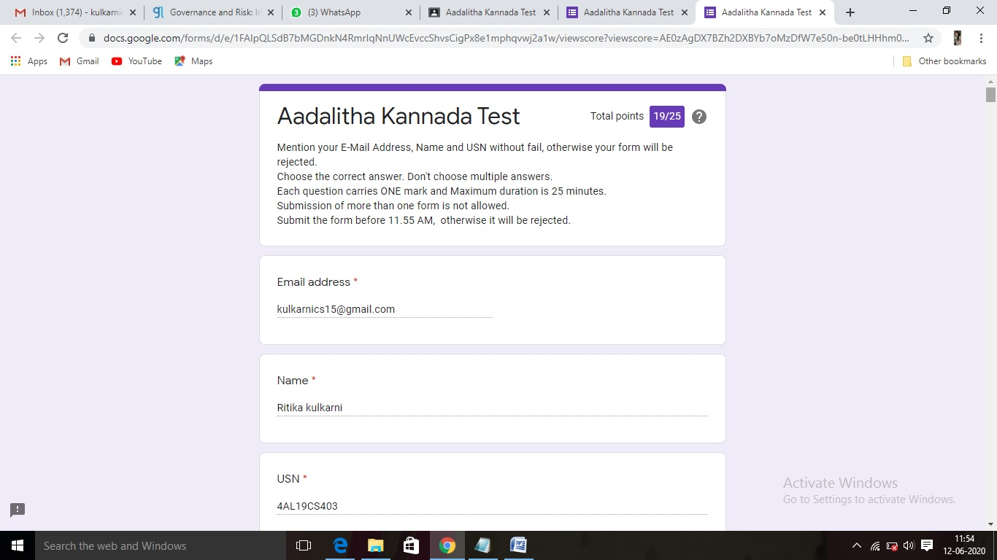

**Certification Course Summary: Today, I went through the Governance and Risk Trends in Cyber Security (Dan Boneh) which helps to execute the code and to achieve the output and some of the basic security commands.**

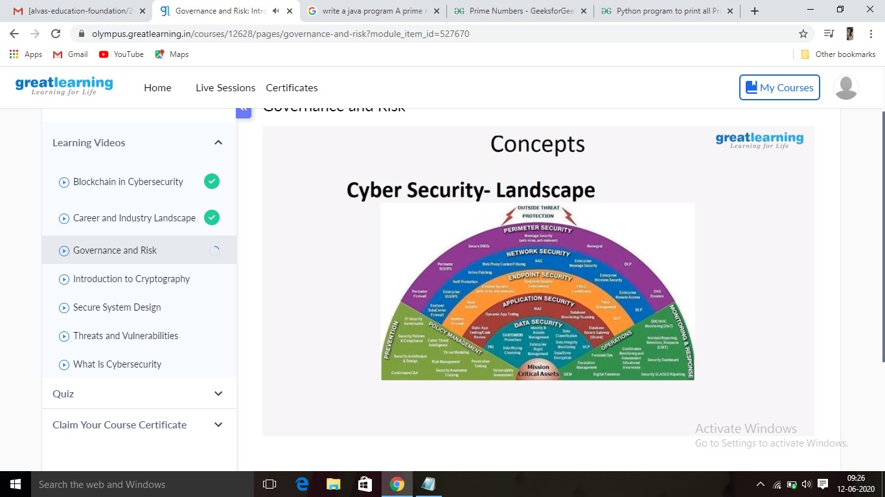

**Online Coding Summary:Online Coding Summary​: Online coding Summary: Today I received two program from Prof.Vasudev CSE Dept. The program is mentioned above(pg.01). to my GitHub repository and I’ve shared the snapshot below.**

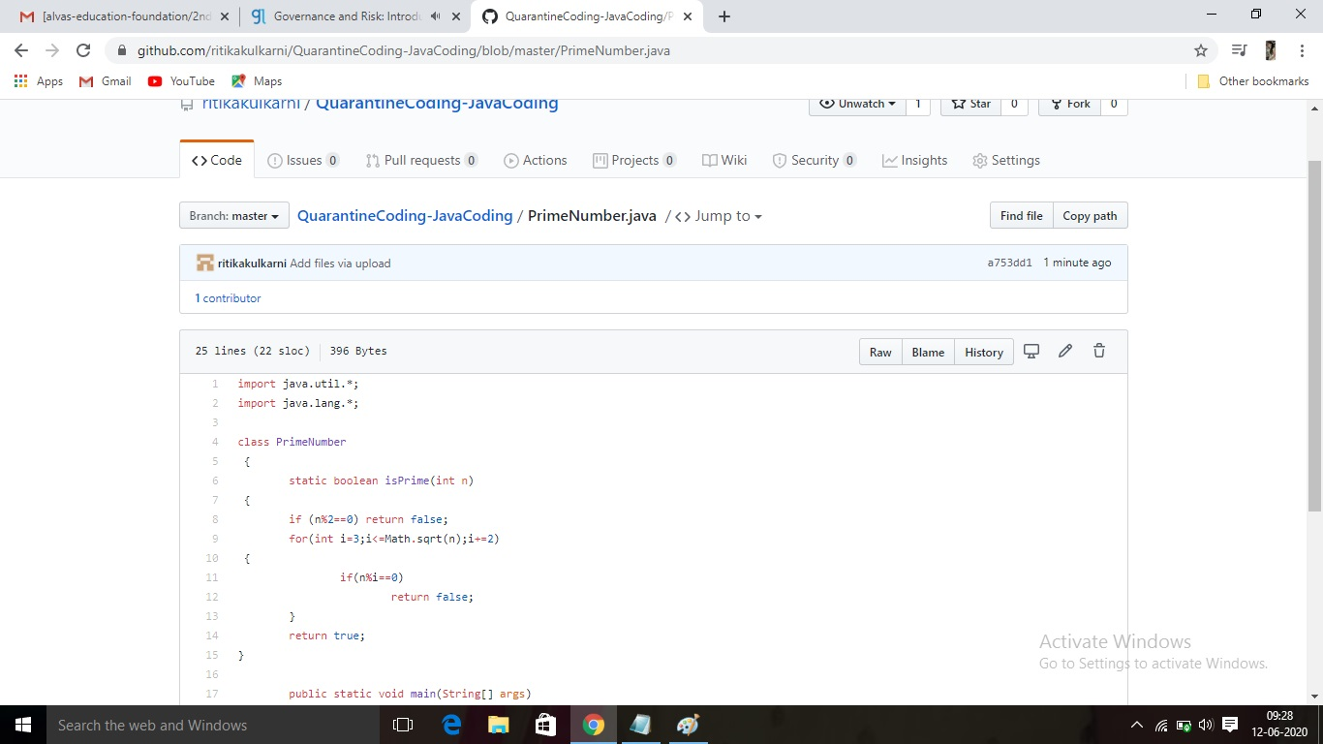 **Thank you.**